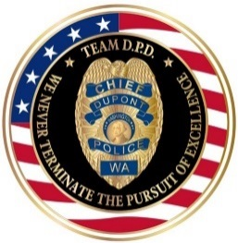 |  | 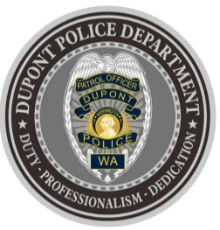
DUPONT POLICE DEPARTMENT
WEEKLY REPORT
Total Calls for Service 6/21/21 – 6/27/21: 166
Average: 23.71 calls per day

EMERGENCY & PATROL INCIDENTS:  - 69 Security Checks/Foot Patrol  - 17 Medical Calls  - 11 Agency Assist  - 5 Wellness Checks  - 3 Motor Vehicle Collisions  - 1 Driving Under the Influence  - 1 Sexual assault  (under investigation) | CRIMES AGAINST PERSONS:  - 1 Domestic Violence – Physical  - 1 Fraud
CRIMES AGAINST PROPERTY:
- 1 Vehicle Prowls
ARRESTS/REFERRED TO PROSECUTOR FOR CRIMINAL CHARGES:
- 1 Domestic Violence – Physical
- 1 Driving Under the Influence (DUI)

DEPARTMENT NEWS:
- Training:
  - One (1) officer undergoing Patrol Field Training
  - Two (2) officers undergoing Basic Law Enforcement Academy Training
- The Emergency Operations Center (EOC) was activated as a “Cooling Center” for the City of DuPont on Saturday and Sunday from 10:00AM until 7:00PM.
- The Department hosted a small (socially distanced) birthday party for Peter. Peter and his family recently moved to DuPont from another country – WELCOME TO DUPONT!
- Officers attended the City of DuPont weekly Farmers Market.

The DuPont Police Department will re-open its door/lobby to the public beginning July 1st.
- If you have a question, we look forward to answering it.
- If you have a concern, we look forward to addressing it.
- If you need assistance and it’s not an emergency, we appreciate the opportunity to assist you.
You can reach us via email at Police@dupontwa.gov or by telephone at 253-964-7060.

REPORTING AN EMERGENCY?
- To report an emergency, dial 9-1-1
- To report a non-emergency, dial (253) 287-4455
- If you aren’t sure, let us help you by dialing (253) 964-7060

COMMUNITY POLICING MESSAGE:

DOWNLOAD THE D.P.D. APP!

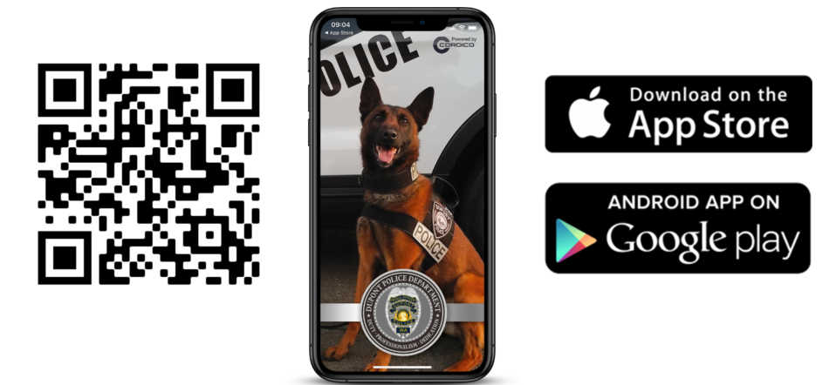
The DuPont Police Department (DPD) will utilize technology to help personnel build resilience and avoid the negative long-term effects of high job-related stress, while also connecting with the public.

The public can access the app to receive general information about DPD and crime prevention.

However, there is a significant wellness portion of the app that is only available to DPD personnel. Powered by Cordico, the leader in public safety wellness technology, the app includes a wellness toolkit addressing 60 behavioral health topics such as fatigue, suicide prevention and alcohol abuse, mental health self-assessments, and videos and guides on yoga, mindfulness, nutrition and more. In addition, the app provides contact information for local therapists who have experience working with first responders, and connects users with the DPD Chaplain & Support Program. DPD Personnel and their families will have confidential, 24/7 access to the app to ensure they have the resources they need in their most difficult moments – on or off-duty. Officers will also have access to a variety of training topics and resources.

The DuPont Police Department joins hundreds of agencies and organizations nationwide served by Cordico.

You can view Chief Newman’s public message introducing the DuPont Police Department app here: https://www.youtube.com/watch?v=HcC2vSlBxeE

