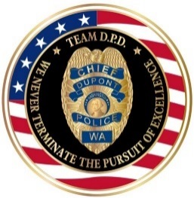 |  | 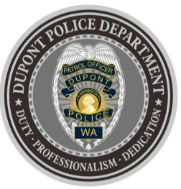
DUPONT POLICE DEPARTMENT
WEEKLY REPORT
Total Calls for Service 7/12/21 – 7/18/21: 177
Average: 25.2 calls per day

EMERGENCY & PATROL INCIDENTS:  - 73 Security Checks/Foot Patrol  - 13 Medical Calls  - 1 Wellness Check  - 1 Motor Vehicle Collision | CRIMES AGAINST PERSONS:  - 4 Domestic Violence (2 Physical, 2 Verbal)
CRIMES AGAINST PROPERTY:
- 1 Vandalism (Garbage left at Park)
- 1 Theft (Catalytic Converter)

ARRESTS/REFERRED TO PROSECUTOR FOR CRIMINAL CHARGES:
- 2 Arrests (1Domestic Violence, 1 Felony Warrant Arrest)
- 1 Referral to Prosecutor (Domestic Violence)

DEPARTMENT NEWS:
- Training:
  - Two (2) officers undergoing Basic Law Enforcement Academy (BLEA) Training
- On-duty officers attended the City of DuPont’s Farmers Market.
- Strong emphasis on patrolling residential areas due to recent catalytic convertor theft.
- Officers conducted a special emphasis for adherence to traffic signs.

The DuPont Police Department is OPEN for walk in traffic!
- If you have a question, we look forward to answering it.
- If you have a concern, we look forward to addressing it.
- If you need assistance and it’s not an emergency, we appreciate the opportunity to assist you.
You can reach us via email at Police@dupontwa.gov or by telephone at 253-964-7060.

REPORTING AN EMERGENCY?
- To report an emergency, dial 9-1-1
- To report a non-emergency, dial (253) 287-4455
- If you aren’t sure, let us help you by dialing (253) 964-7060

