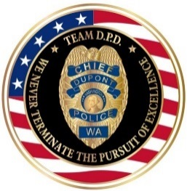 |  | 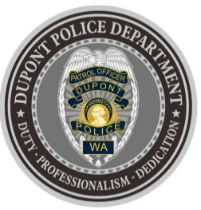
DUPONT POLICE DEPARTMENT
WEEKLY REPORT
Total Calls for Service 7/26/21 – 8/01/21: 189
Average: 27 calls per day

EMERGENCY & PATROL INCIDENTS:  - 79 Security Checks/Foot Patrol  - 15 Medical Calls  - 11 Agency Assist  - 06 Wellness Check  - 03 Motor Vehicle Collisions | CRIMES AGAINST PERSONS:  - 02 Domestic Violence (1 Physical, 1 Verbal)
CRIMES AGAINST PROPERTY:
- 4 Thefts (Catalytic Converter, Merchandise, Package, Motor Vehicle)
- 1 Vandalism
ARRESTS/REFERRED TO PROSECUTOR FOR CRIMINAL CHARGES:
- 02 Arrests (Domestic Violence, Theft of a Motor Vehicle)

DEPARTMENT NEWS:
- Training:
  - Two (2) officers undergoing Basic Law Enforcement Academy (BLEA) Training
  - The department K9 Team participated in a training exercise on JBLM
- On-duty officers attended the City of DuPont Farmers’ Market.
- Officers reviewed 2021 Legislative Updates regarding various changes in Law Enforcement.

The DuPont Police Department is OPEN for walk in traffic!
- If you have a question, we look forward to answering it.
- If you have a concern, we look forward to addressing it.
- If you need assistance and it’s not an emergency, we appreciate the opportunity to assist you.
You can reach us via email at Police@dupontwa.gov or by telephone at 253-964-7060.

REPORTING AN EMERGENCY?
- To report an emergency, dial 9-1-1
- To report a non-emergency, dial (253) 287-4455
- If you aren’t sure, let us help you by dialing (253) 964-7060

