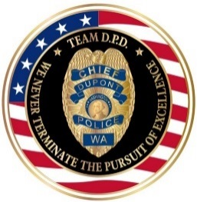 |  | 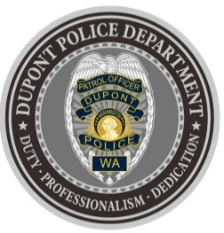
DUPONT POLICE DEPARTMENT
WEEKLY REPORT
Total Calls for Service 8/30/21 – 9/05/21: 180
Average: 25.71 calls per day

EMERGENCY & PATROL INCIDENTS:  - 81 Security Checks/Foot Patrol  - 14 Medical Calls  - 07 Wellness Check  - 07 Agency Assists  - 02 Motor Vehicle Collisions  - 01 Stolen Vehicle Recovery | CRIMES AGAINST PERSONS:  - 01 Domestic Violence (verbal)  - 02 Fraud (Unauthorized utility account/unauthorized bank withdrawal)
CRIMES AGAINST PROPERTY:
- 01 Trespass (from local hotel)
ARRESTS/REFERRED TO PROSECUTOR FOR CRIMINAL CHARGES:
- 01 Arrest (warrants)

DEPARTMENT NEWS:
- Training:
  - One (1) officer undergoing Basic Law Enforcement Academy (BLEA) Training
- Officers attended the last Farmers Market of the 2021 season.
- Officers conducted extra speed emphasis control near the 1800 block of Ridgeview.
- Officers had a presence at Chloe Clark Elementary School for the first day of school.
- A DPD officer attended a child’s birthday party.

The DuPont Police Department is OPEN for walk in traffic!
- If you have a question, we look forward to answering it.
- If you have a concern, we look forward to addressing it.
- If you need assistance and it’s not an emergency, we appreciate the opportunity to assist you.
You can reach us via email at Police@dupontwa.gov or by telephone at 253-964-7060.

REPORTING AN EMERGENCY?
- To report an emergency, dial 9-1-1
- To report a non-emergency, dial (253) 287-4455
- If you aren’t sure, let us help you by dialing (253) 964-7060

