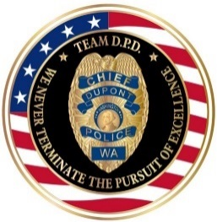 | TWO WEEK REPORT | 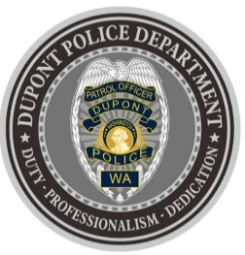
DUPONT POLICE DEPARTMENT
WEEKLY REPORT
Total Calls for Service 9/27/21 – 10/10/21: 397
Average: 28.35 calls per day

EMERGENCY & PATROL INCIDENTS:  - 201 Security Checks  - 20 Medical Aid Calls  - 02 Motor Vehicle Thefts  - 05 Wellness Checks  - 02 Stolen Vehicle Recovery  - 05 Motor Vehicle Collision | PERSON CRIMES:  - 02 Domestic Violence (1 physical, 1 verbal)
PROPERTY CRIMES:
- 02 Shoplift
- 01 Burglary
- 01 Robbery*
- 01 Vandalism
- 17 Vehicle Prowls
OTHER OFFENSES:
• 01 Trespass
ARREST OR REFERRED TO PROSECUTOR:
- 01 Arrest (domestic violence)

***Attempt to Identify: Robbery Suspects 10/08/21***
On October 8th, 2021 at approximately 7:40pm three subjects entered the T-Mobile store located at 1175 Center Dr. One of the individuals implied a weapon, while demanding access to thousands of dollars of merchandise. Store employees were forced to comply with the suspect’s demands. All three suspects who entered together subsequently stole the merchandise and fled the scene on foot.
If you have any information, please contact Detective Hilary Gordon: 253-912-5225 / Hilary.Gordon@DuPontWA.gov
You may view photos of the suspects contain within a DPD public information bulletin at: https://www.facebook.com/DuPontPolice/photos/a.1788717524691787/3113164315580428/

*CRIME ALERT: DuPont Police Department (DPD) has both discovered and responded to multiple vehicle prowls within our city. A majority have occurred in the Hoffman Hill area and at our local hotels, and we have reason to believe they are occurring during the hours of darkness in the very early morning hours. DPD is conducting high visibility patrols in the areas of concern in an attempt to deter this activity and identify possible suspects, and we are working with our local hotels on guest prevention tips. If you have information, please call SGT Bernante at 253-964-7060, extension 5265.

Don’t be an easy target of crime! Help DPD help you and your community from becoming victims. Practice the following tips whenever possible:

- KEEP YOUR DOORS LOCKED AT ALL TIMES.
- CLOSE and lock your garage door.
- PARK vehicles in a garage or well-lit area.
- REMOVE all personal/valuable items from your vehicle.
- KEEP exterior lights on to deter criminal behavior.
- REPORT any (ALL) suspicious activity!
- To report in-progress criminal or suspicious activity, dial 9-1-1.
- To report criminal activity or suspicious activity the is NOT in-progress, dial 253-287-4455.
- If you have any questions or are unsure who to call, dial 253-964-7060.
- For more crime prevention tips, visit our website:
https://www.dupontwa.gov/595/Safety-Crime-Prevention

DEPARTMENT NEWS:
- Training:
  - Two (2) officers currently undergoing Field Training
- The department hosted Washington State Tactical Officer’s Association SWAT Basic course for law enforcement officer from across the state.
- The department hosted A Central Computerized Enforcement Service System (ACCESS) class.
- A DPD Officer/Instructor conducted TASER recertification training for a partner Pierce County police agency.
- Increased patrols of areas of concern due to rash of vehicle prowls.
- The department conducted Lateral Officer Oral Board interviews.
- An informational bulletin regarding vehicle prowls was distributed to local businesses.
- Extra patrols were conducted in business areas, parking lots and residential areas to combat vehicle prowls.

The DuPont Police Department is OPEN for walk in traffic!
- If you have a question, we look forward to answering it.
- If you have a concern, we look forward to addressing it.
- If you need assistance and it’s not an emergency, we appreciate the opportunity to assist you.
You can reach us via email at Police@dupontwa.gov or by telephone at 253-964-7060.

REPORTING AN EMERGENCY?
- To report an emergency, dial 9-1-1
- To report a non-emergency, dial (253) 287-4455
- If you aren’t sure, let us help you by dialing (253) 964-7060

