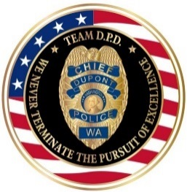 |  | 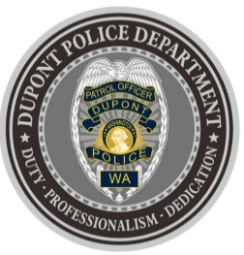
DUPONT POLICE DEPARTMENT
WEEKLY REPORT
Total Calls for Service 10/18/21 – 10/24/21: 198
Average: 28.29 calls per day

EMERGENCY & PATROL INCIDENTS:  - 111 Security Checks  - 05 Agency Assists  - 05 Medical Aid Calls  - 04 Wellness Checks  - 02 Motor Vehicle Collisions | PERSON CRIMES:  - 05 Domestic Violence (2 physical, 3 verbal)
PROPERTY CRIMES:
- 02 Vehicle Prowls
- 02 Stolen Vehicles
- Stolen Property (Investigation ongoing)*
ARREST(s) OR REFERRAL(s) TO PROSECUTOR:
- 05 Arrests (possession of a stolen vehicle, possession of stolen property, warrants, obstruction, domestic violence) *

DEPARTMENT NEWS:
- Training:
  - Two (2) officers currently undergoing Field Training
  - The department hosted Human Trafficking training conducted by the Pierce County Prosecutors Office
- Increased patrols to high traffic areas to deter additional vehicle prowls

***PUBLIC AWARENESS: POLICE INCIDENT: 10/21/21 (STOLEN PROPERTY INVESTIGATION)***

As a result of recent, increased crimes impacting DuPont, to include incidents of vehicle break-ins and stolen/recovered vehicles over the past few weeks, the DuPont Police Department (DPD) has been conducting special emphasis, directed patrols.

On October 21, 2021, at approximately 2:40am, one of these DPD patrol units noticed two vehicles traveling in tandem within the area of the 900 block of Center Drive. Through a vehicle registration check, the DPD unit was able to identify these vehicles were stolen. The DPD unit followed both vehicles until they eventually parked at the Chevron Gas Station, located at 1275 Center Drive. Multiple DPD units responded in an attempt to make contact with the occupants of the stolen vehicles (four subjects in total).

The driver of one of the stolen vehicles exited the vehicle and was defiant and non-compliant with the DPD officer’s verbal commands. This suspect obtained the keys from the driver of the other stolen vehicle and fled the scene towards I-5. Based on newly enacted state law, DPD Officers did not use force to stop this suspect, nor did they attempt to give chase to the second stolen vehicle that fled the scene.

The three remaining suspects were compliant and arrested on a variety of charges, to include Obstruction of a Law Enforcement Officer, Possession of Stolen Property, Possession of Burglar Tools and Possession of Dangerous Weapons. In addition, one of the suspects had an active warrant for Resisting Arrest out of Thurston County, and another suspect had an active warrant for Child Molestation in the 1st Degree out of King County. All three were booked into jail by the DuPont Police Department.

Multiple items of evidence were recovered from the remaining stolen vehicle. While this is an active investigation and we are working with multiple outside police agencies in attempts to identify additional crimes, we have reason to believe that some of the evidence recovered may be connected to several stolen vehicles and car break-ins that have occurred recently within DuPont.

DPD Officers and investigators are currently working on this case. Through their efforts, they have already located and recovered a stolen vehicle, which was reported stolen in DuPont on Wednesday, October 20, 2021 and located in Tacoma the following day.

We will update the public if more information arises from this case.

The DuPont Police Department is OPEN for walk in traffic!
- If you have a question, we look forward to answering it.
- If you have a concern, we look forward to addressing it.
- If you need assistance and it’s not an emergency, we appreciate the opportunity to assist you.
You can reach us via email at Police@dupontwa.gov or by telephone at 253-964-7060.

REPORTING AN EMERGENCY?
- To report an emergency, dial 9-1-1
- To report a non-emergency, dial (253) 287-4455
- If you aren’t sure, let us help you by dialing (253) 964-7060

