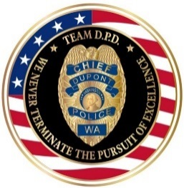 |  | 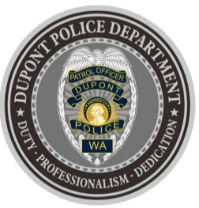
DUPONT POLICE DEPARTMENT
WEEKLY REPORT
Total Calls for Service 10/25/21 – 10/31/21: 167
Average: 23.85 calls per day

EMERGENCY & PATROL INCIDENTS:  - 64 Security Checks  - 12 Medical Aid Calls  - 04 Wellness Checks  - 03 Agency Assists  - 02 Motor Vehicle Collisions  - 02 Stolen Vehicle Recoveries | CRIMES AGAINST PERSONS:  - 02 Domestic Violence (DV)
PROPERTY CRIMES:
- 08 Vehicle Prowls
- 02 Stolen Vehicles
- 01 Theft
ARRESTS OR REFERRALS TO PROSECUTOR:
- 03 Arrests (Felony DV/Assault 1, Possession of motor vehicle theft tools, possession of burglary tools, driving while license suspended/revoked 2nd)

DEPARTMENT NEWS:
- Training:
  - Two (2) officers currently undergoing Field Training
  - One (1) officer attended training to become a Field Training Officer (FTO)
- Increased patrols to high traffic areas to deter additional vehicle prowls
- The department participated in the City of DuPont Parks & Recreation Downtown Trick or Treating event
- Officers performed a special emphasis patrol in residential neighborhoods for Halloween

***CRIME INFORMATION ADVISORY: 10/28***
In response to ongoing vehicle break-ins, stolen/recovered vehicles and property crime within our City, DPD continues high-visibility emphasis patrols in an attempt to combat this criminal activity, which is plaguing the entire region.

On 10/27/21 at approximately 8:20pm, a DPD patrol unit was able to make contact with an occupied suspicious vehicle, parked within the 1500 block of Wilmington Drive. Upon contact, and through a records check, the DPD officer was able to confirm the vehicle was stolen out of Tacoma. Multiple backup units responded, and the occupants (an adult male and adult female) were taken into custody.

It was also discovered that the male suspect had an active felony warrant for Assault out of the Washington Department of Corrections. Both occupants were in possession of window punches (commonly used to break car windows during car prowls), and "shaved keys" (used to start various models of cars during the commission of stealing a vehicle).
The occupants were arrested, booked into jail and charged with the following:
• Possession of Stolen Property
• Possession of Burglar Tools (×2)
• Possession of Stolen Motor Vehicle Tools (x2)
• DOC Felony Warrant for Assault

We will continue to update the public if more information emerges from this, or of any other significant public safety incident. In addition, DPD emphasis patrols will continue, depending on staff availability and resources. In the meantime, please follow these crime prevention tips:

• KEEP YOUR DOORS LOCKED AT ALL TIMES.
• CLOSE and lock your garage door.
• PARK vehicles in a garage or well-lit area.
• REMOVE all personal/valuable items from your vehicle.
• KEEP exterior lights on to deter criminal behavior.
• REPORT any (ALL) suspicious activity!
• To report in-progress criminal or suspicious activity, dial 9-1-1.
• To report criminal activity or suspicious activity that is NOT in-progress, dial 253-287-4455.
• If you have any questions or are unsure who to call, dial 253-964-7060 (Monday through Friday, 8:00 a.m. to 5:00 p.m.).
• For more crime prevention tips, visit our website:
https://www.dupontwa.gov/595/Safety-Crime-Prevention

The DuPont Police Department is OPEN for walk in traffic!
- If you have a question, we look forward to answering it.
- If you have a concern, we look forward to addressing it.
- If you need assistance and it’s not an emergency, we appreciate the opportunity to assist you.
You can reach us via email at Police@dupontwa.gov or by telephone at 253-964-7060.

REPORTING AN EMERGENCY?
- To report an emergency, dial 9-1-1
- To report a non-emergency, dial (253) 287-4455
- If you aren’t sure, let us help you by dialing (253) 964-7060

