 |  | 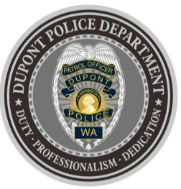
DUPONT POLICE DEPARTMENT
WEEKLY REPORT
Total Calls for Service 11/29/21 – 12/05/21: 229
Average: 32.71 calls per day

EMERGENCY & PATROL INCIDENTS:  - 101 Security Checks  - 08 Agency Assists  - 04 Wellness Checks  - 01 Motor Vehicle Collision | CRIMES AGAINST PERSONS:  - 02 Domestic Violence
PROPERTY CRIMES:
- 02 Failure to Yield
- 01 Vehicle Prowl
- 01 Vandalism
- 02 Trespass
ARRESTS OR REFERRALS TO PROSECUTOR:
- 03 Arrests (failure to have ignition interlock X2, harassment)

DEPARTMENT NEWS:
- Training:
  - Two (2) officers currently undergoing Field Training.
  - Officers worked on completing online training assigned by both the department and the City
- Extra patrols were conducted for the annual tree lighting event held at the 1500 block of Wilmington Drive
- The department hosted Social Media, IP Address and Cell Phone Exploitation training

The DuPont Police Department is OPEN for walk in traffic!
- If you have a concern, we look forward to addressing it.
- If you have non-urgent questions, suggestions, want to file a complaint or commend a D.P.D. staff member, we appreciate the opportunity to assist you.
You can reach us via email at Police@dupontwa.gov or by telephone at 253-964-7060.

REPORTING AN INCIDENT? NEED AN OFFICER?
- To report an emergency, dial 9-1-1
- To report a non-emergency, dial (253) 287-4455
- If you aren’t sure, let us help you by dialing (253) 964-7060

