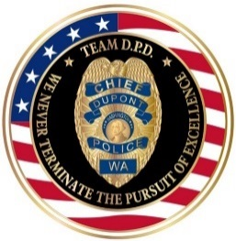 |  | 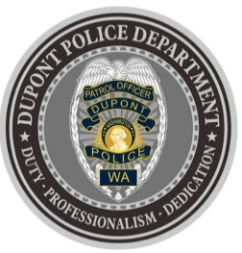
DUPONT POLICE DEPARTMENT
WEEKLY REPORT
Total Calls for Service 12/13/21 – 12/19/21: 200
Average: 28.57 calls per day

EMERGENCY & PATROL INCIDENTS:  - 92 Security Checks  - 05 Agency Assists  - 03 Wellness Checks  - 03 Motor Vehicle Collision  - 01 Stolen Vehicle Recovery | CRIMES AGAINST PERSONS:  - 02 Domestic Violence
PROPERTY & OTHER CRIMES:
- 01 Vehicle Prowl
- 01 Trespass
- 01 Possession of Stolen Vehicle
- 01 Unlawful Possession of a Firearm
ARRESTS OR REFERRALS TO PROSECUTOR:
- 03 Arrests (Department of Corrections Warrant, Possession of Stolen Vehicle & Possession of Burglary Tools, Criminal Trespass 1st)
- 01 Referral to Prosecutor (Unlawful possession of a Firearm & Unlawful Carry of a Concealed Weapon)

DEPARTMENT NEWS:
- Training:
  - DPD welcomed a new officer to the team. The Department now has two (2) officers currently undergoing Field Training.
- The department hosted A Centralized Computer Enforcement Service System (ACCESS) Training.
- On 12/17/21, Officers conducted a special emphasis presence patrol of local schools for reported threats of violence within schools nationwide from social media. There were no specific threats to any schools in DuPont, and the date of the threats passed without incident.

REPORTING AN INCIDENT? NEED AN OFFICER?
- To report an emergency, dial 9-1-1
- To report a non-emergency, dial (253) 287-4455
- If you aren’t sure, let us help you by dialing (253) 964-7060
If you have non-urgent questions, suggestions, want to file a complaint or commend a D.P.D. staff member, we appreciate the opportunity to assist you. You can reach us via email at Police@dupontwa.gov or by telephone at 253-964-7060.

FROM THE DESK OF THE CHIEF: DPD’S 2021 TOYS FOR TOTS CAMPAIGN WAS AN OVERWHELMING SUCCESS BECAUSE OF YOU!
THANK YOU, DUPONT! For the second year, DPD participated in the Marine Forces Reserve Marine Toys for Tots Foundation drive, supporting the mission that no child will be without a gift this holiday season. Thanks to our friends at Patriots Landing, this year FAR EXCEEDED the contributions from the last year – with over four full boxes of gifts!
This campaign was only successful because of the generous contributions from our unbelievable DuPont residents and friends. My thanks to all of the staff at DPD who supported this year’s effort, especially SGT Dan Saboe (a former Marine himself) for spearheading this meaningful project. Again, THANK YOU, DUPONT!

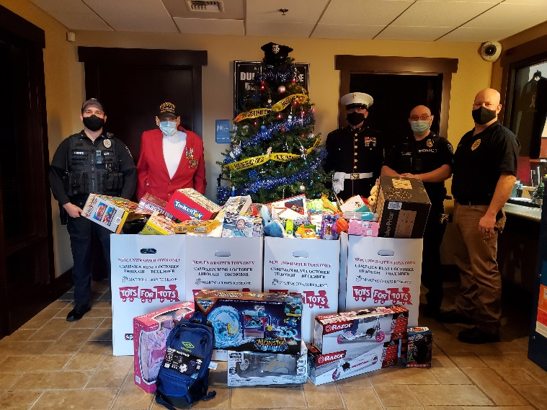

CRIME UPDATE – 12/16/2021
DPD crime suppression emphasis patrols continue. On 12/15/2021, just before 9:30pm, DPD officers noticed a vehicle which matched the description of a vehicle that fled (failed to yield) from DPD officers several weeks prior when officers attempted to make a traffic stop. This time, DPD officers observed the vehicle (registered to an owner in Lacey) and waited for it to park in the parking lot of a local hotel, and for the occupants to exit. DPD officers made verbal contact with the individual they observed exiting the driver’s seat. As a result of this field investigation, it was discovered through a criminal records check that the subject was wanted for a felony warrant: Escape from Department of Corrections Community Custody for Unlawful Possession of a Firearm. DPD officers immediately took this subject into custody based on the valid arrest warrant. As part of the arrest, a frisk was conducted and DPD officers found a loaded .40 caliber handgun concealed in the subject’s waistband. Suspected illegal narcotics were also found (pending crime laboratory testing). The firearm and suspected drugs were seized as evidence. Additional felony charges are being prepared by DPD for submission to the Pierce County Prosecutor’s Office. GREAT WORK BY DPD PATROL – THANK YOU!
