 |  | 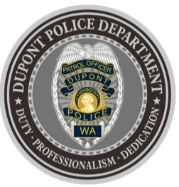
DUPONT POLICE DEPARTMENT
WEEKLY REPORT
Total Calls for Service 12/20/21 – 12/26/21: 199
Average: 28.42 calls per day

EMERGENCY & PATROL INCIDENTS:  - 103 Security Checks  - 08 Agency Assists  - 04 Motor Vehicle Collision  - 03 Medical Aid | CRIMES AGAINST PERSONS:  - 01 Domestic Violence
PROPERTY & OTHER CRIMES:
- 03 Vehicle Prowls
- 01 Motor Vehicle Theft
- 01 Shoplift
- 01 Theft
- 01 Failure to Yield
ARRESTS OR REFERRALS TO PROSECUTOR:
- 02 Arrests (Felony Department of Corrections Warrant, Assault 4 Domestic Violence)

DEPARTMENT NEWS:
- Training:
  - The Department now has two (2) officers currently undergoing Field Training.
- Several of the officers completed training on the new use of force simulator.
- Officers responded to several vehicle collisions over the holiday weekend due to the significant snowfall.

REPORTING AN INCIDENT? NEED AN OFFICER?
- To report an emergency, dial 9-1-1
- To report a non-emergency, dial (253) 287-4455
- If you aren’t sure, let us help you by dialing (253) 964-7060
If you have non-urgent questions, suggestions, want to file a complaint or commend a D.P.D. staff member, we appreciate the opportunity to assist you. You can reach us via email at Police@dupontwa.gov or by telephone at 253-964-7060.

