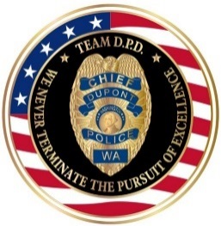 | HAPPY NEW YEAR | 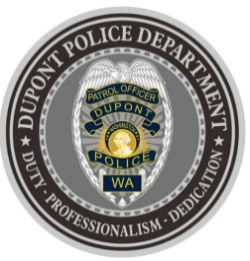
DUPONT POLICE DEPARTMENT
WEEKLY REPORT
Total Calls for Service 12/27/21 – 01/02/22: 167
Average: 23.86 calls per day

EMERGENCY & PATROL INCIDENTS:  - 86 Security Checks  - 03 Motor Vehicle Collisions  - 02 Stolen Vehicle Recovery | CRIMES AGAINST PERSONS:  - 01 Domestic Violence
PROPERTY & OTHER CRIMES:
- 02 Vehicle Prowls
- 03 Motor Vehicle Theft
- 01 Theft
ARRESTS OR REFERRALS TO PROSECUTOR:
- 03 Arrests (Possession of Burglary Tools & Theft of a Motor Vehicle, Reckless & Driving While License Suspended or Revoked, Possession of Motor Vehicle Theft Tools)

DEPARTMENT NEWS:
- Training:
  - The department has one (1) officer undergoing Field Training, and one (1) officer who completed Field Training this week and will be assigned a patrol shift.
- Snowfall caused traffic problems and delays. Extra patrols were conducted at problem intersections/areas to reduce congestion and increase awareness of roadway conditions.

***CRIME AWARENESS REPORT: 12/30***
On 12/30/21 at approximately 9:00 pm, while continuing crime suppression emphasis patrols, a DPD patrol unit located a wanted suspect in the area of Center Dr. and Haskell St. This individual was wanted for a prior vehicle theft from a residence in DuPont. The suspect was immediately taken into custody based upon positive identification and probable cause for the aforementioned DuPont vehicle theft. During the course of the arrest, it was discovered that the suspect was also in possession of burglary tools. This adult male suspect was subsequently booked into the Pierce County Jail for the outstanding motor vehicle theft charge and possession of burglary tools. Great work by DPD Patrol!

DPD NWP IS HERE!!!
ANNOUNCING THE DUPONT POLICE DEPARTMENT NEIGHBORHOOD WATCH PROGRAM:
In partnership with National Neighborhood Watch, we are excited to announce the establishment of the DuPont Police Department Neighborhood Watch Program (DPD NWP).
It is more important than ever to have extra eyes on our community focused on collective public safety. The goal of the DPD NWP is to support groups of people living or working in the same neighborhood who want to make their community safer by working together, and in conjunction with the DuPont Police, reduce crime and improve their quality of life.
Benefits of a Neighborhood Watch Program:
• A great way to become familiar with neighbors.
• Work as partners with the DuPont Police.
• Learn how to recognize suspicious activity within your neighborhood and how to report.
• An opportunity to have neighborhood meetings to help increase communication between neighbors, share information or concerns, and actively engage with DPD officers.
• Receive crime prevention tips and information on how to take proactive steps to reduce the opportunity for crime to occur around your home.
DPD is currently underway in setting up individual neighborhood block and business watch programs within the city. If you are interested in starting a program for your area, visit our DPD NWP webpage at: https://www.dupontwa.gov/641/Neighborhood-Watch-Program
You may also contact our DPD NWP Coordinator, Kelly Limata, directly:
253-964-7060, Ext. #5298 / Kelly.Limata@dupontwa.gov
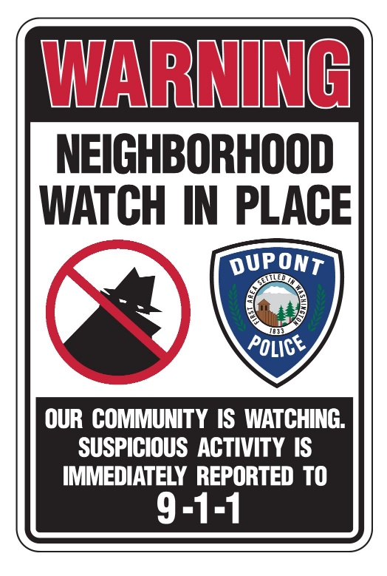

REPORTING AN INCIDENT? NEED AN OFFICER?
- To report an emergency, dial 9-1-1
- To report a non-emergency, dial (253) 287-4455
- If you aren’t sure, let us help you by dialing (253) 964-7060

If you have non-urgent questions, suggestions, want to file a complaint or commend a D.P.D. staff member, we appreciate the opportunity to assist you. You may reach us via email at Police@dupontwa.gov or by telephone at 253-964-7060.

